Hi Team SELAC,

Last Saturday’s session was impressive with so many PB’s and another club record being broken. It was great to see some many kids having fun and competing strongly.

Club Records
Congratulations to Helena Carey for breaking the longstanding club record in the under 7 500m, with a very amazing performance of 1.51.88.

PB’s
Last week 206 new PB’s
This week 247 new PB’s

Special mention goes to these athletes you achieved the highest amount of PB’s Percival Spring (7), Lea Avdishov (5), Hannah Pellow (5), Gigi Remond (5), Chelsea Joseph (5), Billie Moses (5) and Max Davoren (8) and Jackson Glenn (6).
Well done!!

Big News – The Extra Uniforms have arrived and will be on sale this week. Thanks for your patience, everyone!!

The Runners Shop at Randwick will be setting up a pop up shop this Saturday for those who need new shoes, socks, etc.
Robyn and the team have been supporting the club for a couple of years. Go over and say hi! She will look after you!!

Selac Training sessions
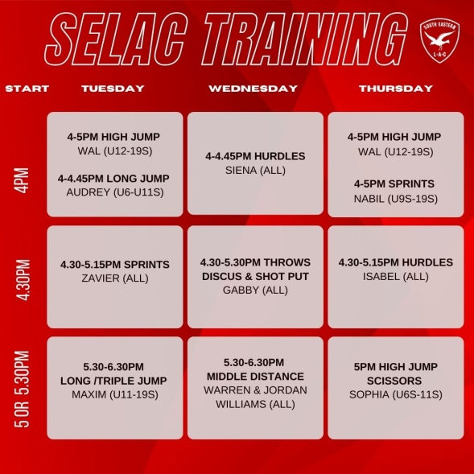
The Selac training sessions have been full swing this week, with 41 athletes signing up and getting along to training. Nabill had 15 athletes along the sprinting session with focus on starting fast! Let’s see what those athletes can do on the weekend!!
With 11 training sessions available for athletes there is something for everyone!!
Please see the training schedule attached and sign up using the link:
https://forms.gle/EGXHQrcDvsG1zG6e7

If you want to attend SELAC sponsored training you need to sign up and pay before you start.

SELACTrials – This is the last week of trials.

Tots Age Marshal - We are still looking to identify an age marshal or 2 people to share the role and take in the tots group. See Matt if you’re interested.

SELAC Senior Athletics Club - Athletes are now able to register to compete in ANSW senior events while representing South Eastern Little Athletics. Please see the link. https://www.revolutionise.com.au/selac/registration/

PB-Athon -The PB-Athon is going great and this is half way point. Keep getting those PB’s.
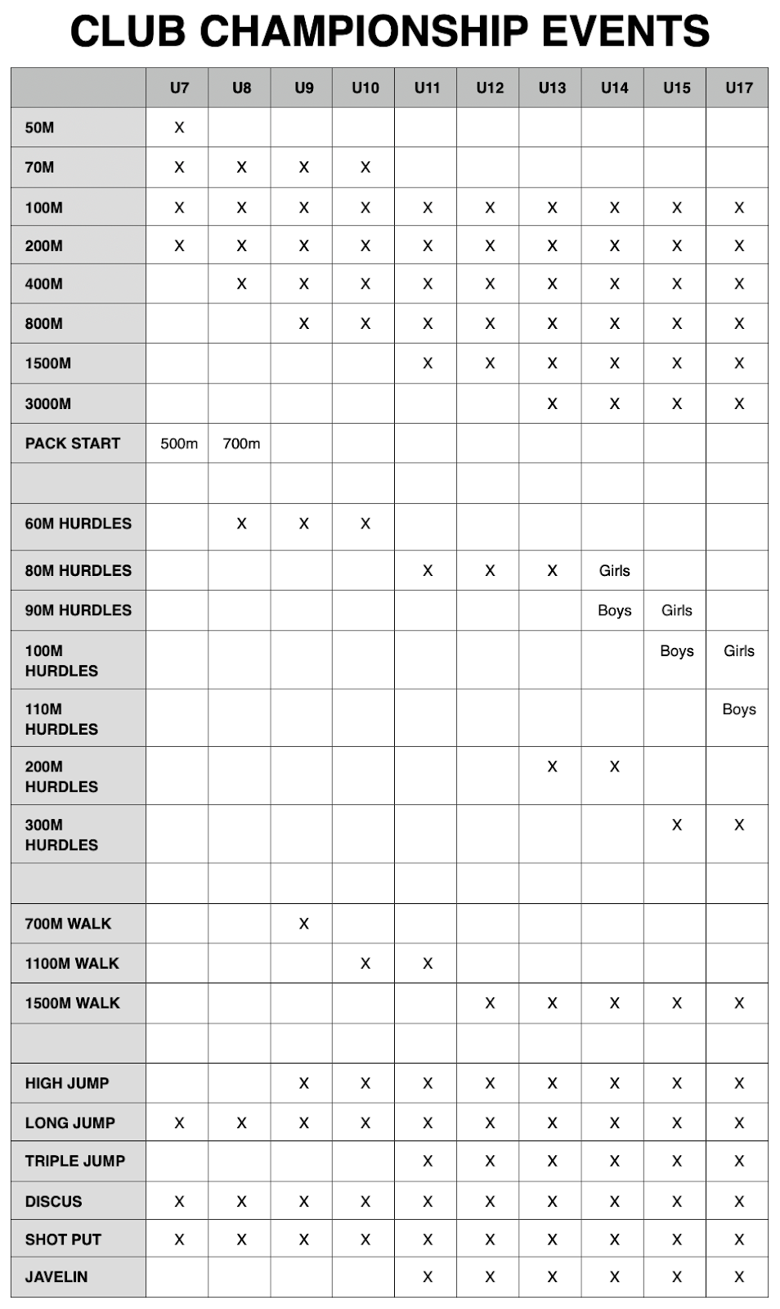
SELAC Club championships
2023 CLUB CHAMPIONSHIPS REGISTRATION IS OPEN!

South Eastern Little Athletics Club Championships will be held over 2 weekends on Saturday 28 October and Saturday 4 November. (with the exception of the 3000m which will be held on another program 1 week). Medals will be awards for 1st, 2nd and 3rd places. Entry cost is $10 per athlete - for up to 5 events.

1. Fill out the form below for the athlete (if you have multiple athletes you will need to complete one form for each).

2. Transfer the appropriate amount to the bank details below:
Instructions for Payment Transfer:
Account Name: South Eastern Little Athletics Centre Inc
BSB: 012-396
Account Number: 4937-13606

Reference: Name and Age Group
A “reference” is essential so we can match the payment to your child.

A single family payment for the total training amount can be made in one transfer and then uploaded with each family athlete registration.
3. Take a screen capture of your transfer and upload via this form.

Entries for the Club Championships close on Wednesday 25 October 2023. Entry here: https://forms.gle/RFQNDauzhJ9D1H6e6

Sponsors – the club is always on the lookout for new sponsors, if you have any thoughts, please contact Matt or Theresa.

Graded Races
At Selac we run graded races in different events, as we have found over time that athletes produce more PB’s when running with those who have times close to theirs.
Generally, there is only 10 sec between all the athletes in a race, which makes for some competitive run and normal a close finish.

This year we are going to start our graded race series with the 800m this Saturday. Click here for the race lists.

General Information;
Track & Field Status (program attached) - We are on program ONE (1) this week.

Registration numbers - Please attach the numbers to uniforms if you have them.

On the Day
Set-up is from 7.15am. Please make sure that as many parents as possible lend a hand to set-up.
Sean will be coordinating the Walks and any seniors that wish to run the 3000m at 7.45am.
8am with the P700 (U8), Graded 800m for U9 upwards. Please see link to the sheet here.

Parent please your child is aware what race they are running in. Anyone without a time will run before the other graded races.

This is followed by the short hurdles on the front straight and 50m and 70m on the back straight. We will finish with the 200m.

See you all on Saturday.

SELAC Committee

